The 25 most popular Urban Legends still being told VWO

During this class, you will watch a video about the 25 most popular urban legends still being told and answer questions about the video.

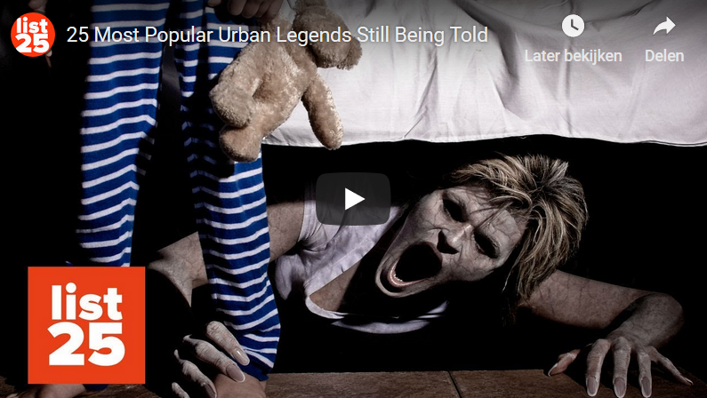

The link to the video:
https://www.youtube.com/watch?v=R7lptczSxPI

VWO

Bloody Mary
1. Why is Bloody Mary decapitated?

Kennedy and the Jellied Donut
2. According to legend, what happened?

3. What two meanings does “Ich bin ein Berliner” have?

The Dissolving Tooth
4. What happens, according to legend, to a tooth if you leave it in a glass of Coca Cola all night?

Walt Disney is Cryogenically Frozen
5. Why would Walt Disney be kept frozen?

Sewer Gators
6. Why did they get rid of the alligators?

7. What era does this legend come from?

The Vanishing Hitchhiker
8. What was so special about the place where the girl was picked up?

The Killer in the Backseat
9. Why did the man in the car blink to the woman?

The Babysitter and the Man Upstairs
10. Where did the man’s phone calls come from?

The Hook
11. Where did the man escape from?

The Clown Statue
12. Who or what is the clown?

The Dead Body Under the Mattress
13. Why did the couple call the reception?

Buried Alive
14. Why does the speaker think this can’t really be called a legend?

15. What is your favourite urban legend? Explain why this is so.

16. Which Urban Legend do you think is the most unbelievable? Explain why.

